Information Architecture Report

Prepared by: Brittany Nowicki, Rutgers University
Program: MBS, User Experience Design
Course: Information Architecture
Release Date:
Version: 1

www.brittnowicki.com

Table of Contents

Table of Contents 1
Preliminary Research: ThoughtCatalog.com 2
User Personas 5
Competitive Analysis 7
Sitemap 8
TreeJack – Sitemap Testing Study 12
Stress Test 15
Wireframes: Current 18
Heuristic Evaluation 22
Updated Site Map and Rationale 25
Card Sorting Test 27
Wireframes: Redesign 31
Executive Summary 33

Preliminary Research: ThoughtCatalog.com

URL of the Website : https://thoughtcatalog.com/
Assess Website/business intent - Goals and objectives
ThoughtCatalog’s mission is to be a platform for “thoughtful storytelling”. They post articles, submitted by aspiring as well as seasoned writers and give people an outlet to connect and read stories and list articles about current events/topics as well as personal essays. They have over 100k articles and 20k writers. They also support featured writers in book publication and run a sister platform called QuoteCatalog - highlighting writers from their site as well as well known/famous authors and poets. In addition, they run a platform called Collective.World. This is where writers can make a profile to submit articles and also have a feed of features articles
Below are ThoughtCatalog’s Ideals. Number 2 and 4 are key to strategically developing their IA.
- Thought Catalog contributors should strive to make their writing fun, smart, and creative, i.e., entertaining, journalistic, and literary.
- The site should be clean and clutter-free.
- We believe all thinking is relevant and strive for a value-neutral editorial policy governed by openness. The more worldviews and rhetorical styles on the site, the better. We want to tell all sides of the story and generate dialogue.
- We’re about today. But our mission is also archival. We want to catalog the times for tomorrow.
- We want to help shape culture by empowering you to share your ideas and stories with the world.

Assess user's intent to use the website
Users that visit the site are there to read and submit articles. With a variety of content, the site attracts a broad range of readers. With personal stories, the site attracts readers looking for connection and community. It also attracts writers looking to gain visibility - it produces writers and articles with millions of views/reads.
Assess the content
- The homepage of the website is cluttered with content.
  - Also show Ads
- There is little labeling/division of types of content
  - Top of the page features a series of articles about 1 category
- The Navigation Bar
  - Social Media Icons: Instagram, Facebook, Apple, Twitter
  - Hamburger Menu - Top right corner - High Level Navigation?
    - Shows different topics than on Homepage Navigation
      - About, Submissions/ Homepage, Popular, Latest, Writers, Books
      - Only place with e-mail submission for newsletters
      - Social Media Icons - different platforms, and in a different order
  - Homepage Button - Top left corner
  - Latest
    - Page with articles listed in chronological order from when they were posted on the site.
    - Also shows sister platforms, not otherwise advertised: HeartCatalog, CreepyCatalog, AstrologyCatalog
  - Writers
    - Featured - has pictures and Bio’s of ThoughtCatalog Editors/Featured writers with consistent stories and viral content
    - All - directs users to a new tab with 425 pages of writers, listed alphabetically
  - Books
    - Takes users to seperate site called ShopCatalog where users can buy books published by the site
  - Quotes
    - This takes users to their other platform QuoteCatalog
  - Instagram
    - Since the site is on multiple Social channels it should not be exclusive to 1 outlet
- Homepage separates contect into “blocks” and lists.
  - Featured Story - possibly top story?
  - Trending Now - list of top 10 trending articles - heat mapped by color
  - Featured Quote
  - We’re Talking About…
    - Seems broken down by a tag or category
  - Editor’s Picks - shown with a Gallery Scroll
  - We’re Reading…
    - Seems to be articles from other sources/sites
  - ThoughtCatalog Videos
  - Featured Book?
    - Can’t tell what this section is unless you click the button that says “CLICK HERE” - takes you to Shop Catalog
  - Creepy
  - Astrology
  - More to Explore..
    - Broken into boxes of popular tags
  - ThoughtCatalog Classics
    - Also known as “Popular” in some areas
    - Button for “More Storeis→”
  - Sponsored Ad
  - Bar with Top Tags (I think)
  - Footer with more links
    - Copyright
    - Content
    - Company
    - Legal
    - Search Bar

User Personas
Persona 1: Alexa, Passive Reader
Demographics: Millennial
- 18
- Female
- Single
- College Student: Freshman
Behaviors/Objective:
- Stumbles on content through social media feeds; Facebook, Twitters
- Visits site between classes, or before bed
Served by:
- Personal Topics about: college, relationships, friendship, finding yourself

Background:
Alexa is a Freshman at Rutgers University, finding her foot and taking core corses before declaring a major. Her hobbies include shopping, reading, and partying with friends. She is friends with her 3 roommates and they eat, sleep, and do everything together. Alexa reads ThoughtCatalog on her MacBook and her iPhone. Most of the time she clicks on an article from Twitter and then stays on the site to browse other similar articles about college, dating, and “finding your passion”.
Persona 2: Julia, Featured Writer/Editor
Demographics: Millennial
- 26
- Female
- In a Relationship
- College Graduate: English Degree
- Occupation: Freelance Writer

Behaviors/Objective
- Publishes multiples articles a week
- Commissioned/Paid for content
- Published works with viral views turned into books

Served by
- Large Audience, High Volume Readership

Background:
Julie is a college graduate with various freelance jobs writing articles and stories for local magazine and website with a large audience base. She love that she is able to make money doing what she loves. Her hobbies include writing, reading memoirs and psychology books, and yoga. ThoughtCatalog has publishes hundreds of her articles and has published her most viewed/read articles and poems into books. She is an Editor at ThoughtCatalog as well and approved new writers’ submissions through Collective.World platform.

Persona 3: John, Aspiring Writer
Demographics: Millennial
- 22
- Male
- Recently Single
- College Graduate: Journalism & Communication
- Occupation: Bank Teller
Behavior/Objective
- Submits daily writing pieces in hopes of being accepted
- Few stories have been Featured on the homepage
- Increase views of each article/develop writing voice
Served by
- Large Audience/Readership
- Notoriety

Background:
John just graduated college and is in the process of applying for jobs. His hobbies include playing basketball, video games, and he dabbles in writing. He has recently been submitting stories and articles to ThoughtCatalog about topics for Millennials, and has found himself somewhat successful and hopes to continue and improve his craft. John mainly uses the Desktop version of the site because the app has very limited feature.

 | Thought Catalog | Elite Daily | Bustle | Medium
Value Proposition  Product  /Service | Writing Platform, Blog/Submission Based | Writing Platform, Blog/Submission Based | Writing Platform, News/Blog, Paid Writers | Writing Platform, Blog/Self Publish, Broad Audience
Design | Minimal  Black & White | Minimal  Black & White | Minimal  Black & White  *Purple Ombre Menu | Minimal  Black & White
Layout | Responsive  Varied, single column homepage  *Boxes separating categorized content | Responsive,  Varied Grid Layout  *Separated by categorized content | Resposive  Varied, Single column homepage  *Articles separated by ‘Issues’/Serial Content | Responsive  Varied homepage  Categories Pages – Grid Layout
Organization/IA | Top Navigation  Main Menu  Homepage | Main Menu  Homepage | Main Menu  Homepage | Top Navigation  Homepage  *No Main Menu
Search Accessibility | *Hard to find  Search bar in footer | *Magnifying glass icon  Top of page next to Menu | *Magnifying glass icon  Top of page next to Menu | *Magnifying glass icon  Top of page next to Menu
Labeling | Homepage - Low | Homepage – Moderate  Articles Categorized by Topic | Homepage – None  Single Stream | Homepage - Moderate
Content Topics | Articles Tagged  Findability – Low  *nontraditional categories | Articles Categorized/Tagged  Findability – High  *traditional categories | Articles Categorized/Tagged  Findability – High  *traditional categories | Articles Categorized/Tagged  Findability – High  *traditional categories  *Users can follow topics when logged into their profile
Competitive Analysis

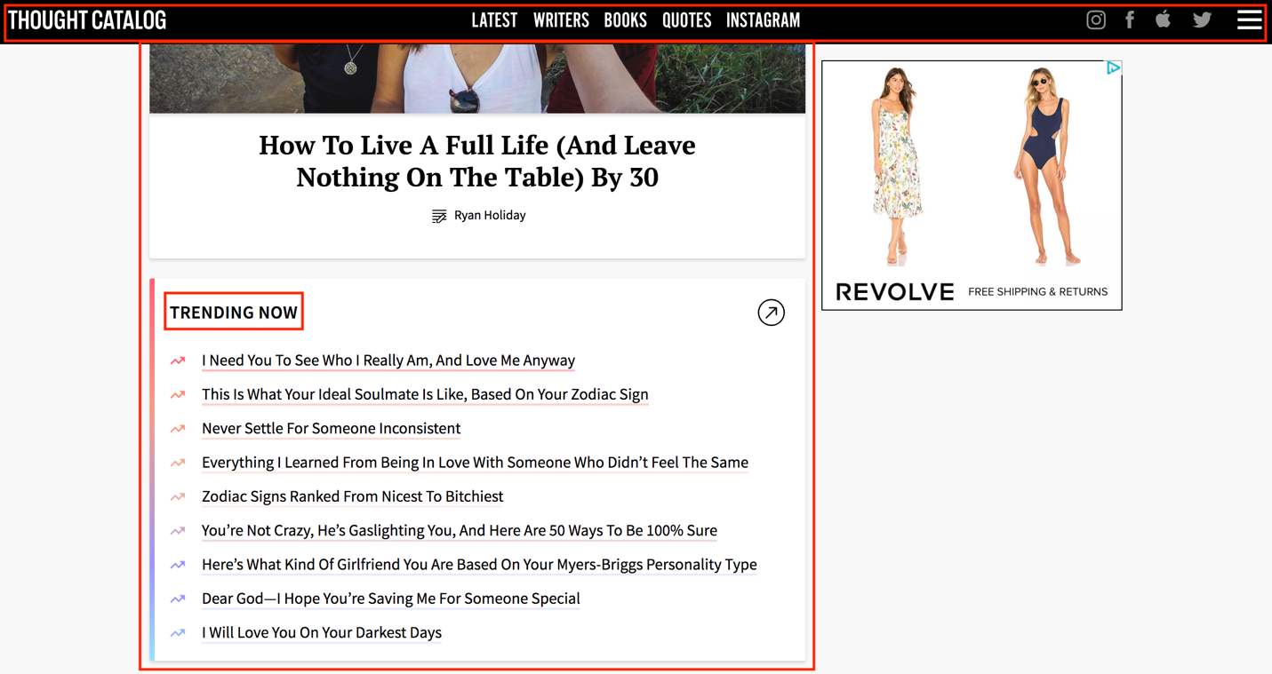

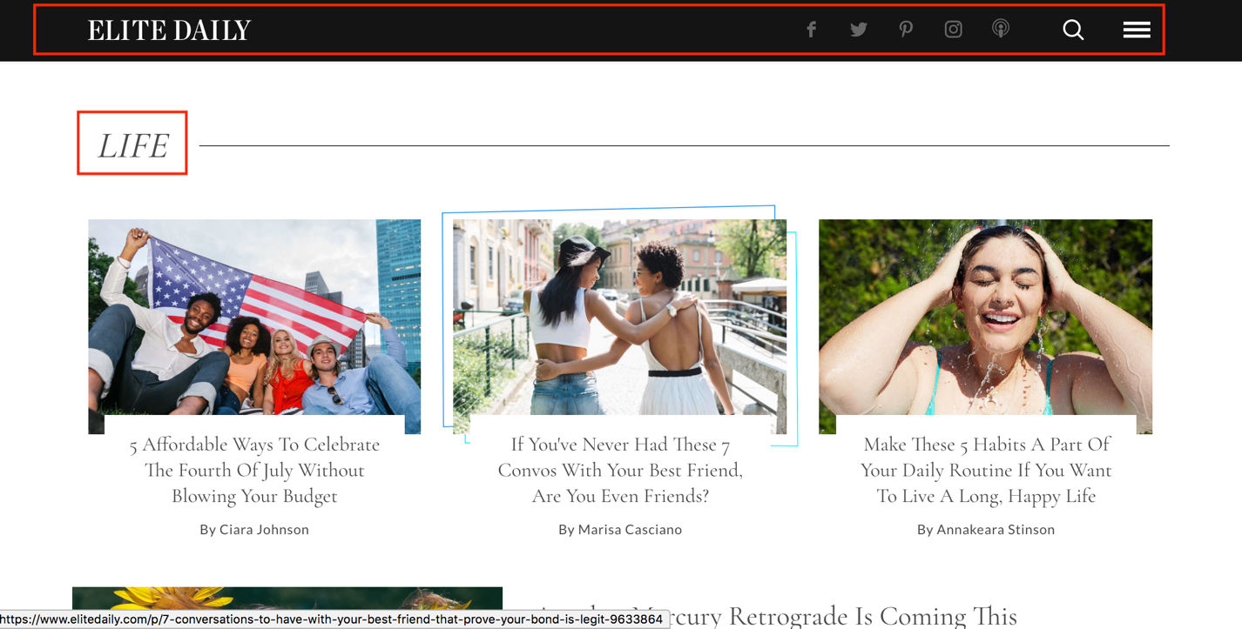
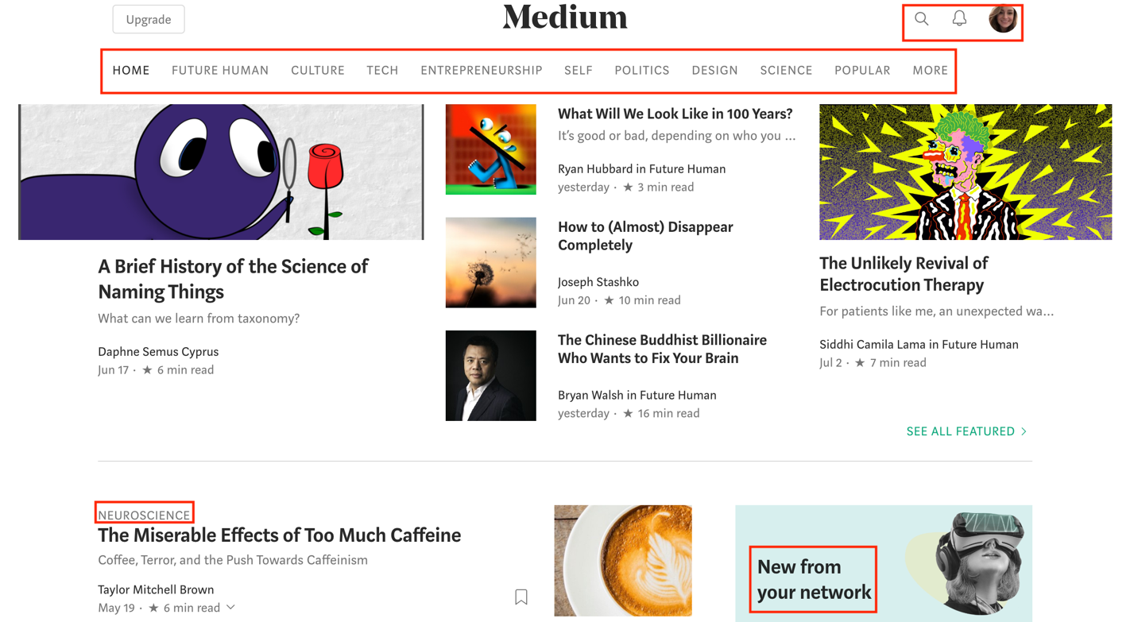

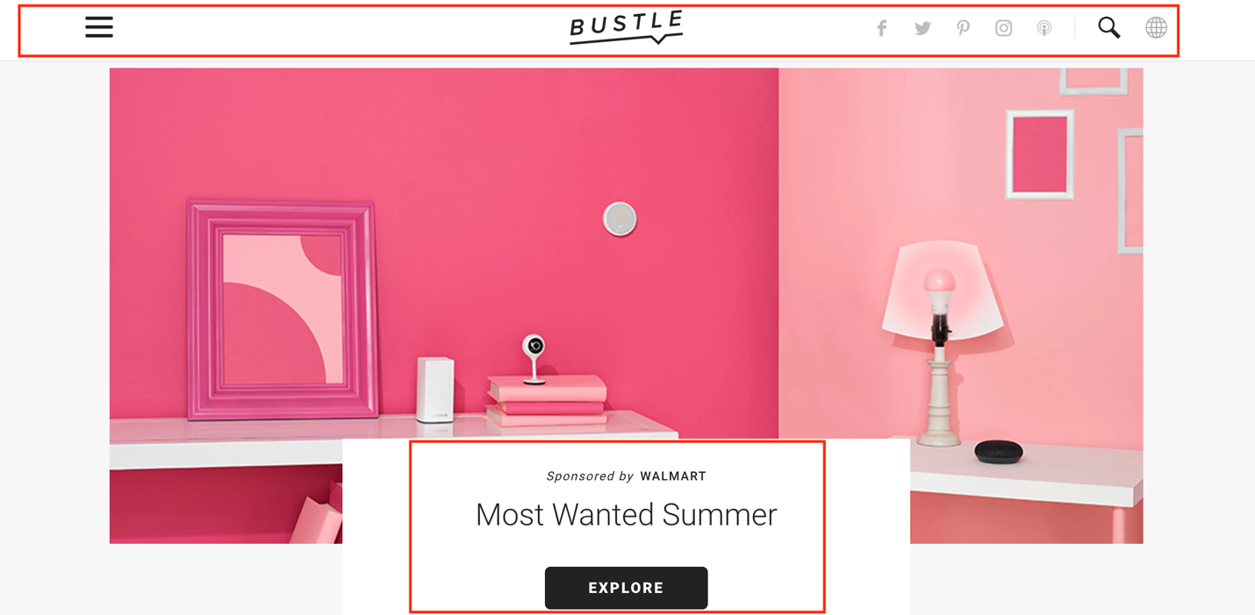

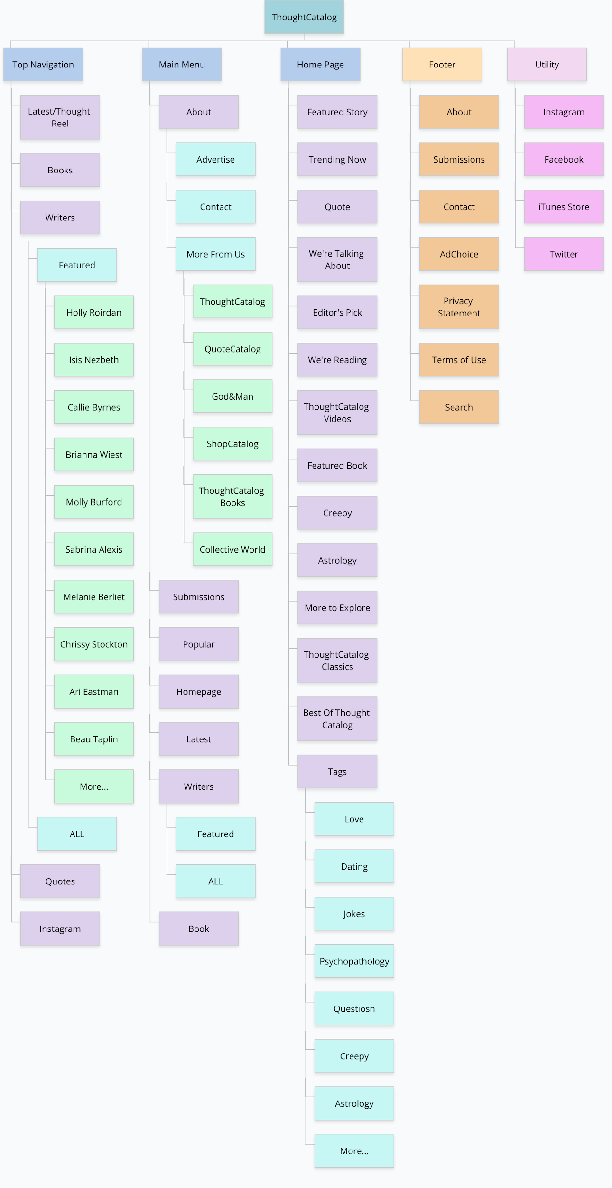
Sitemap

TreeJack – Sitemap Testing Study

At A Glance:
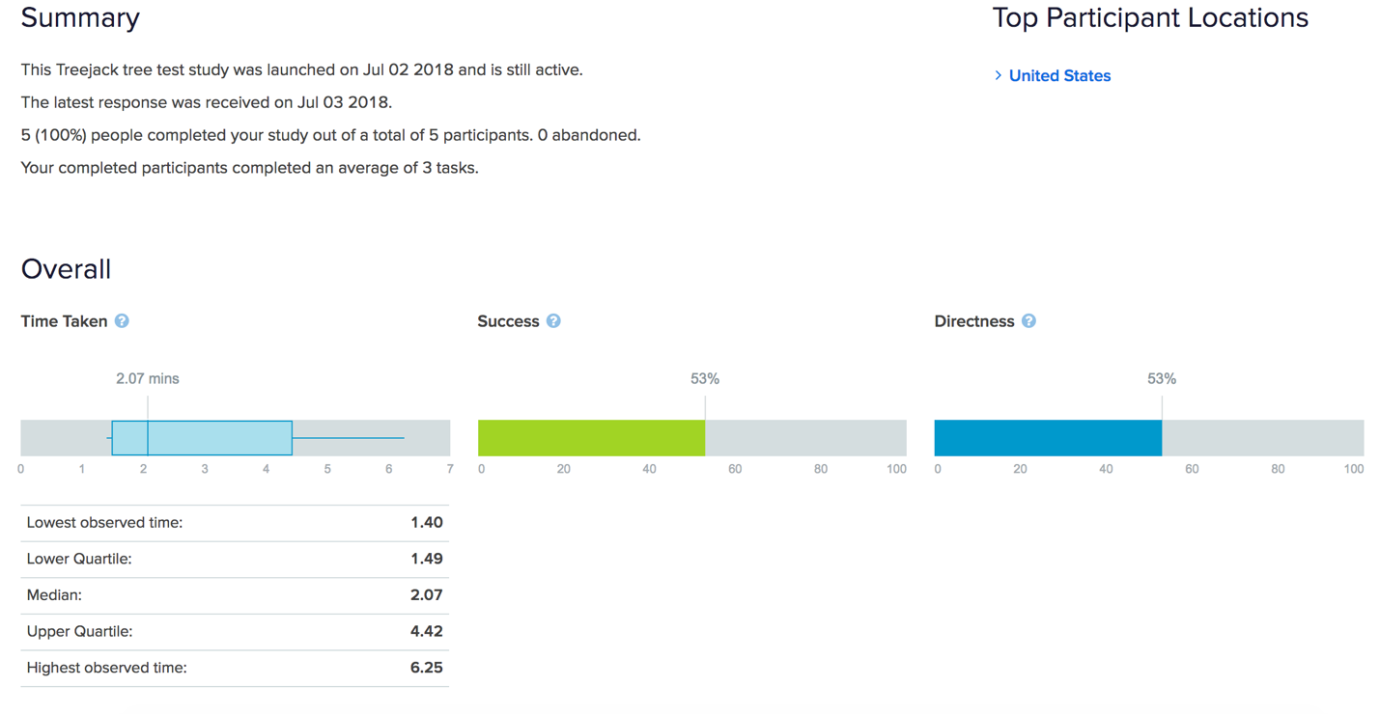
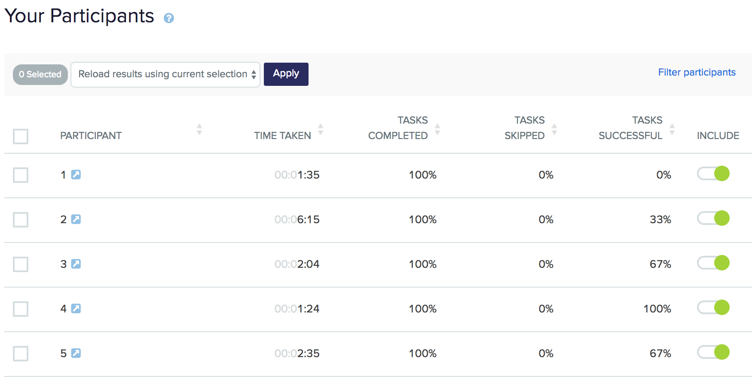
*Only 1 participant correctly completed the set of tasks

Question 1 was intended for users to explore the cumbersome “Writers” section of the site. The Featured Author’s page does have Chrissie Stockton’s name on it, but in no particular order do they seem to be listed. If you wanted to look her up by her first of last or name, knowing for sure she would be listed under All Authors, you would have no way of sorting the Authors by letter, never mind first or last name.

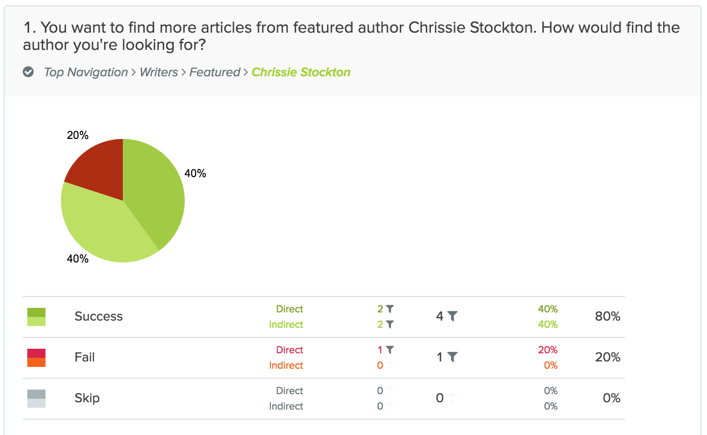

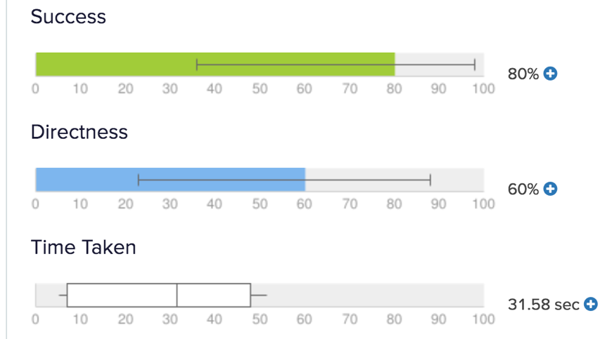
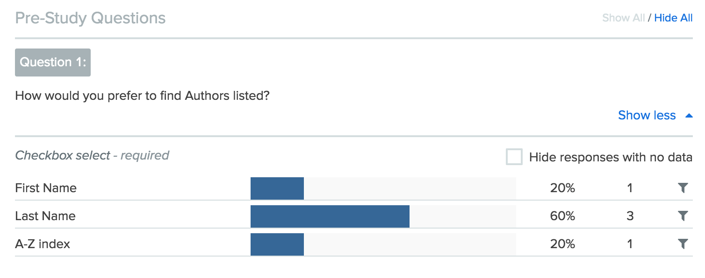

Questions 2 was intended to demonstrate the inconsistent labeling in “Latest” articles and the page itself being called the “Thought Reel”. There was a 40% fail rail in this trial.

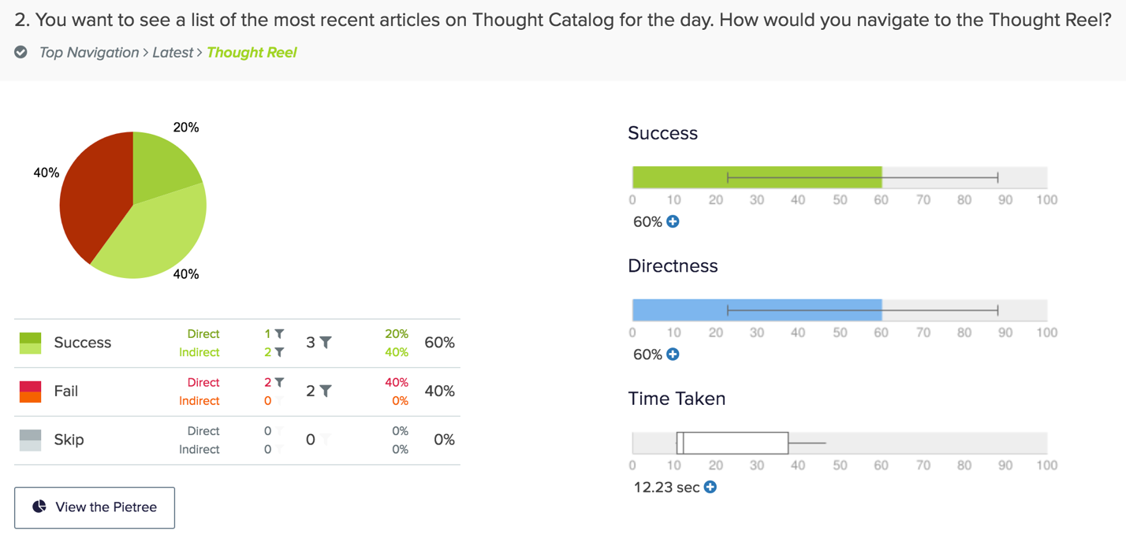

Question 3 was intended to demonstrates the various ambiguous language used to label different categories of articles. There was only a 20% success rate in completing this task. At further examination of the paths, very few were taken directly to the correct answer.
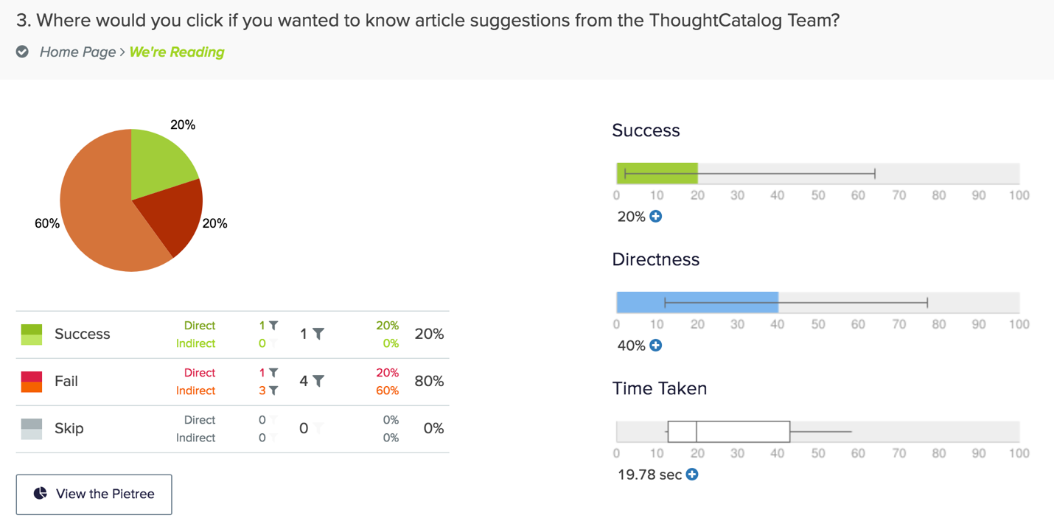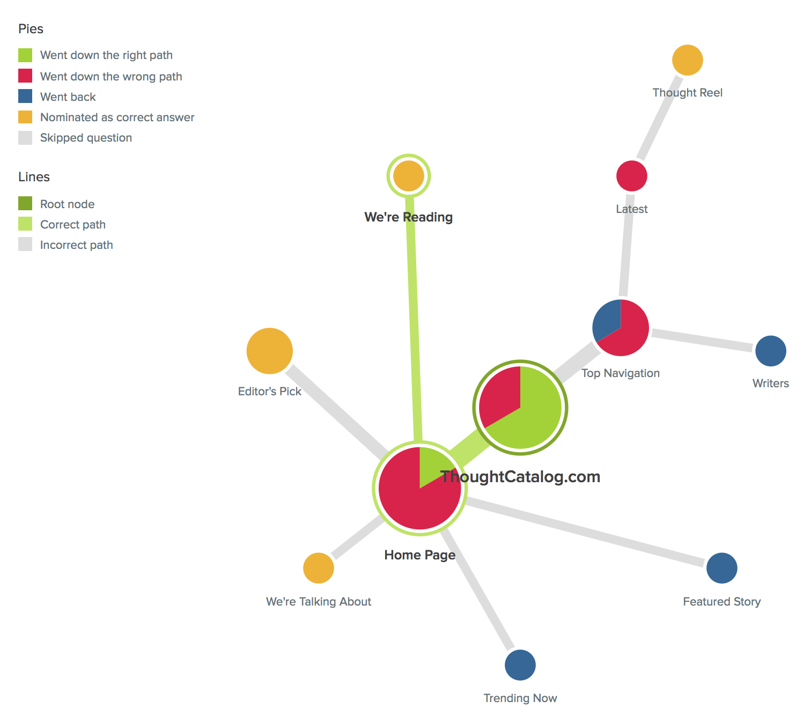

Stress Test

Since ThoughtCatalog.com is primarily site for personal essay articles, this stress test tries to demonstrate the limited access to specific articles. The only direct ways to find content that isn’t immediately displayed on the homepage is to go through the Author’s profiles page, which is not organized by category or title; it is organized by most recent post (which is not uncommon), but since the search bar is at the very bottom of the home page, it is not easily accessible to search keywords or simply the author to find what you’re looking for.

Key:
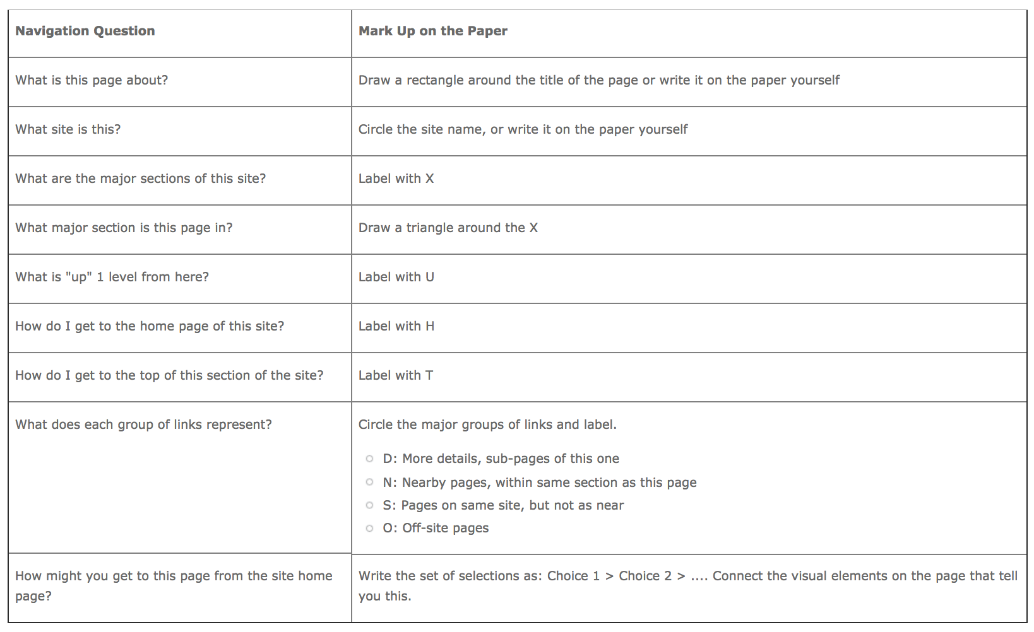

As a note, the images below of the stress test have been cropped to incorporate only the relevant information for this test. The body of the article was quiet cumbersome and the page in it’s entirety can be found at: https://thoughtcatalog.com/christine-stockton/2018/06/road-trip-games/

The above photo demonstrate elements of the stress test; in particular, the breadcrumb trail of how you would access this page. It also shows that there are two main ways to navigate and also notes that many paths in the main navigation header take you to pages outside of the ThoughtCatalog website.

The below photo shows the content at the bottom of the articles. The author, her external connection pages, other articles that seemingly have similar topics, ads, and the footer, which directs you to other sister company pages of ThoughtCatalog: ShopCatalog, QuoteCatalog and ThoughtCatalog Books.

Wireframes: Current

Below are wireframes of the 4 most accessible pages on the ThoughtCatalog website.
Homepage
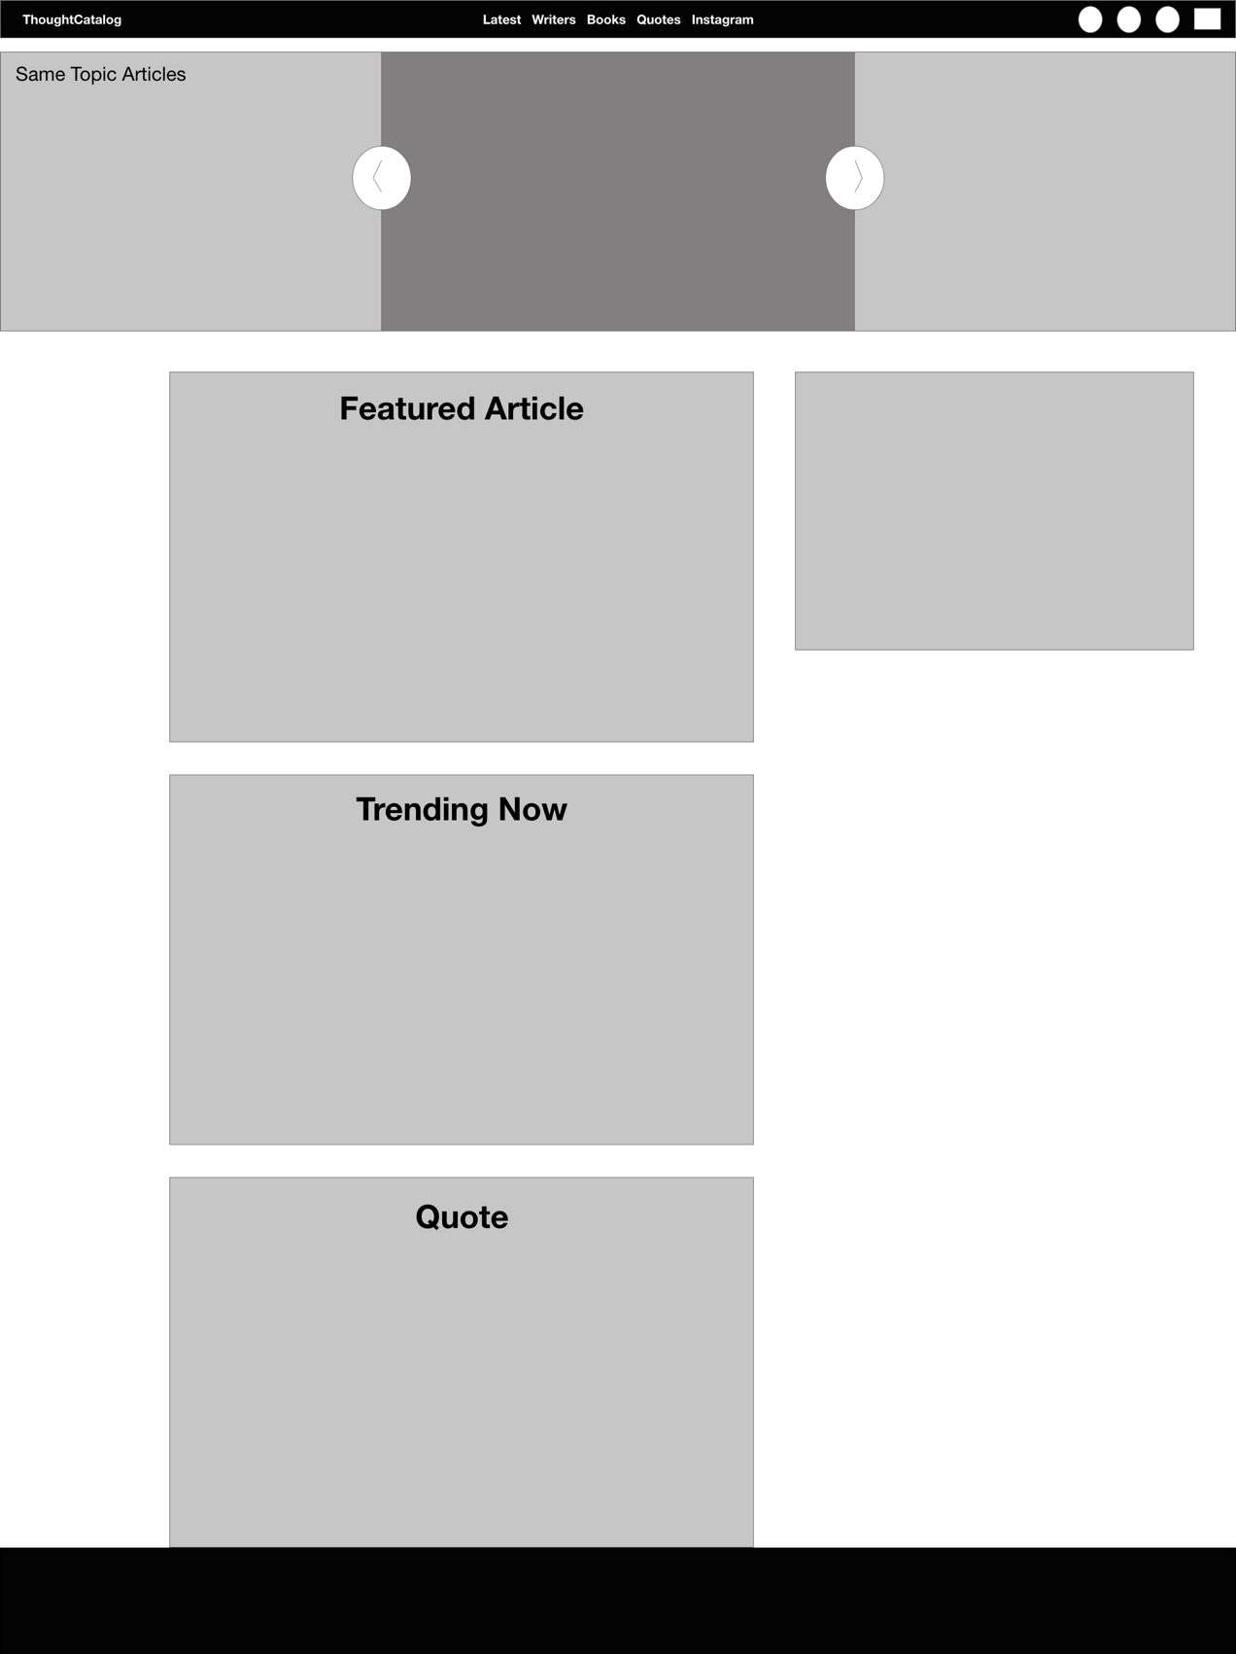
Latest Articles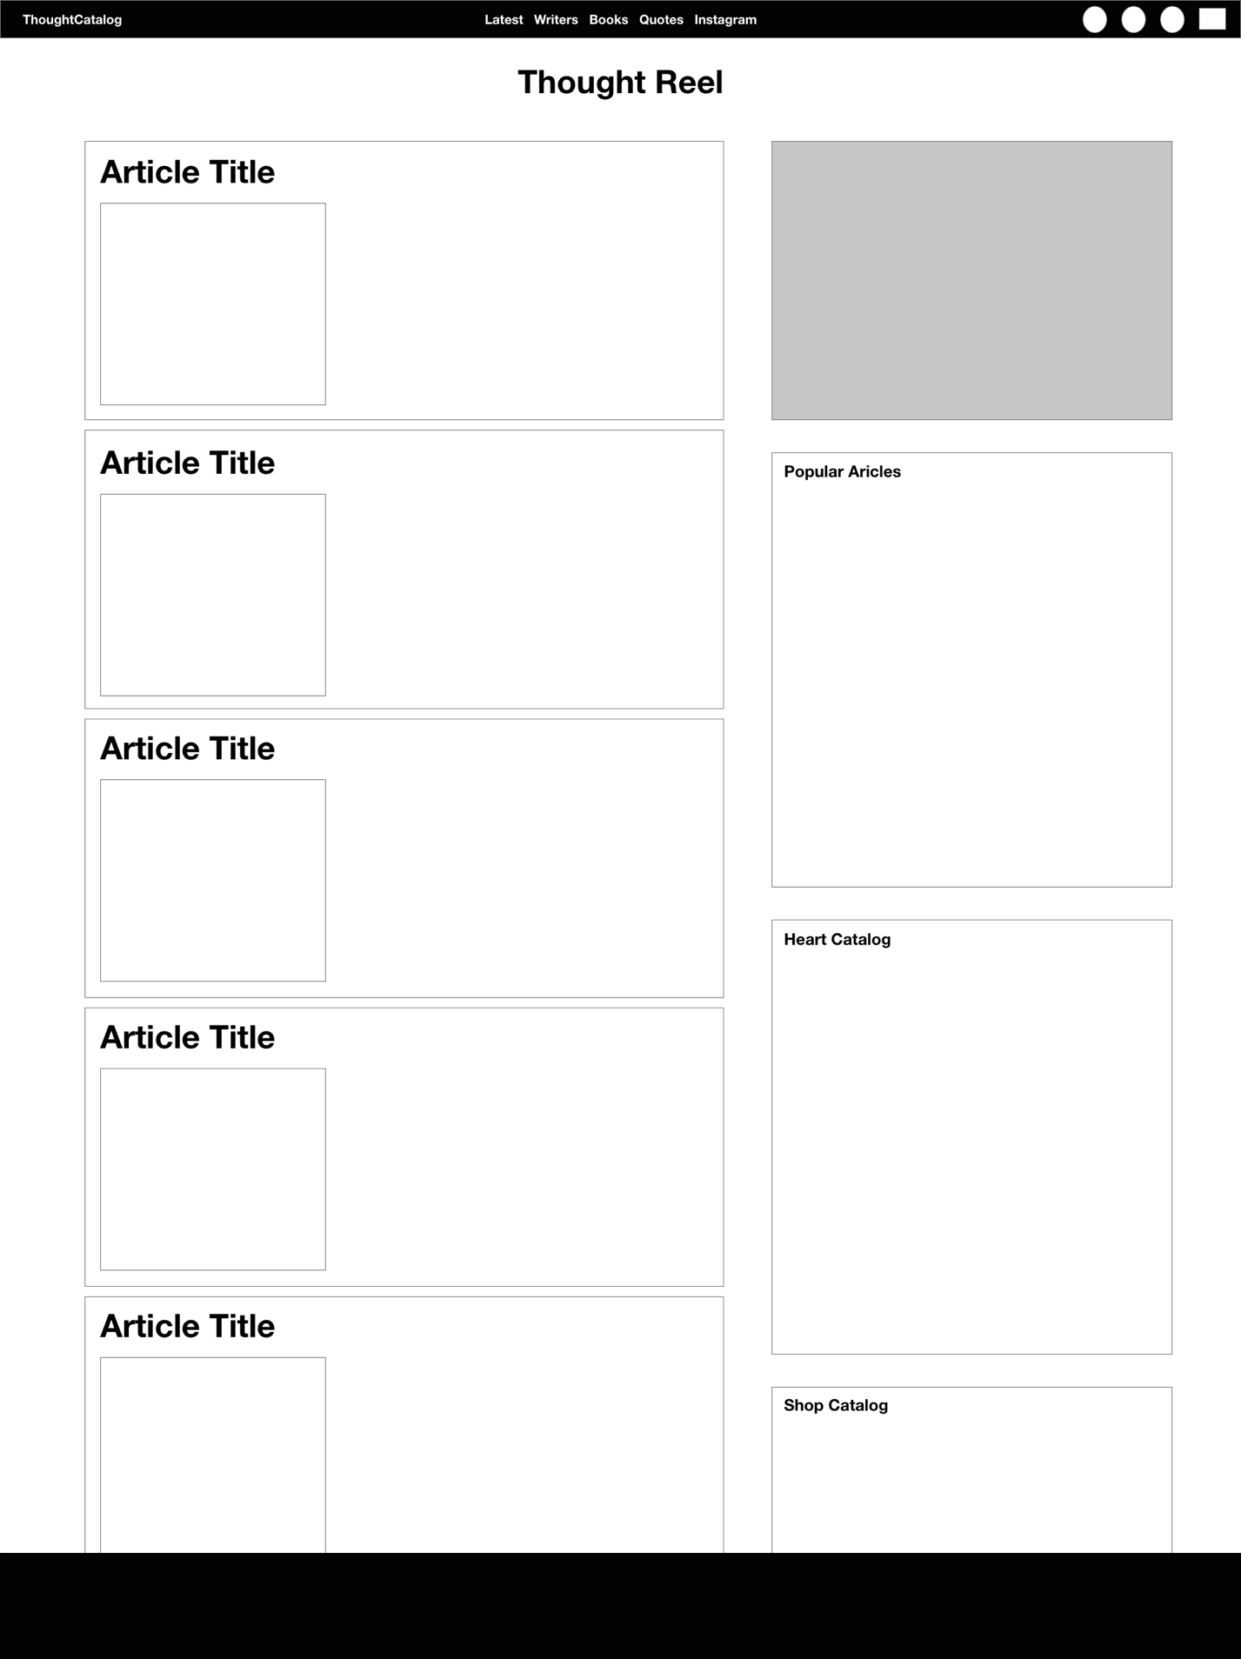
Writers – Featured page automatically shows when you click the main page link.
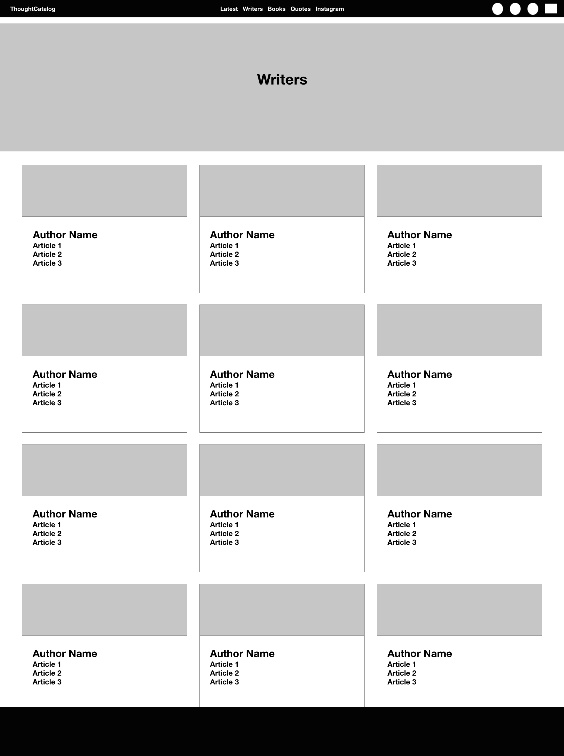
Article
Heuristic Evaluation

An evaluation of the ThoughtCatalog website was conduction to determine specific areas of trouble and improvement. In the absence of users, conducting a heuristic evaluation allows for the analysis of a design with users in mind. While there are several sets of heuristics with which you can examine a piece of software, the following report will illustrate our findings upon the conclusion of an evaluation specifically utilizing the ISO 9241 heuristics. Below is the criteria used to conduct the evaluation for reference throughout the report.
ISO 9241 Heuristics for Usability Design
H1 | Suitability for the Task
H2 | Self-Descriptiveness
H3 | Controllability
H4 | Conformity with User Expectations
H5 | Error Tolerance
H6 | Suitability for Individualization
H7 | Suitability for Learning

Problem Severity Rating
0 | Not a Usability Problem
1 | Cosmetic Problem
2 | Minor Usability Problem
3 | Major Usability Problem
4 | Usability Catastrophe

- Benefits
  - Helped further explore the interface thoroughly
  - Provided quick and inexpensive feedback
  - Discovered more general issues with the interface & interactions
- Issues
  - Website’s basic purpose did not lend to objectives of the test
  - Couldn’t find more relatable problems
  - Uncovered a lot of trivial issues
As a items of note, only select few heuristics were able to be correctly applied.

H2 – Self-Descriptiveness
- 2 – Search Field offers prompting or dialog.
  - Many search bars auto suggest when the user starts typing for easier searching and defined results
  - Suggestion: Implement auto complete.
- 1 – Search Bar very minimalistic and hard to find
  - Not a bit alteration is needed – simply cosmetic. I would suggest relocating the search bar for effortless access to user queries.
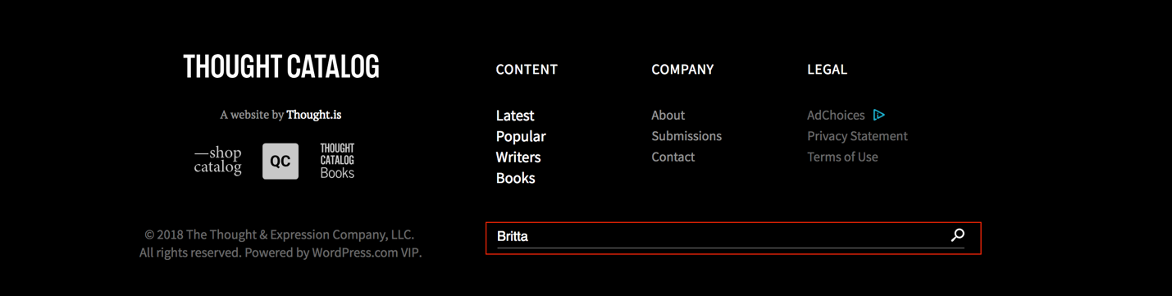

H4 – Conformity with User Expectations
- 2 – Labeling Inconsistencies
  - Latest/Thought Reel
  - Homepage Category boxes
    - As we saw in the TreeJack study, label inconsistencies with the site, seem to be the most common problematic issue. Ambiguous labels and titles can lead to failing user expectations.
  - Suggestion: Easy fix would be to transition titles of pages, breadcrumb trails, navigation to consistent names.
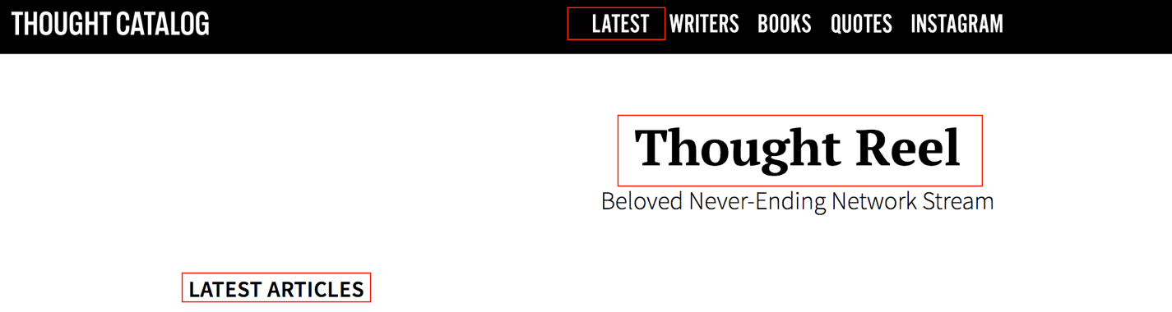

H6 – Suitability for Individualization
- 3 – Submissions platform is a separate site and there depletes
  - Currently ThoughtCatalog does not support personalization of users like some of their competitors.
  - Suggestion: ThoughtCatalog would benefit from integrating their third party submission platform with their main website. The experience can be greatly improved by letting users sign up for accounts, follow topics, tags, writers they like and allow them to individualize their experience. This would allow for customized feeds and less ambiguous boxes on the homescreen to try and grab readers attention.

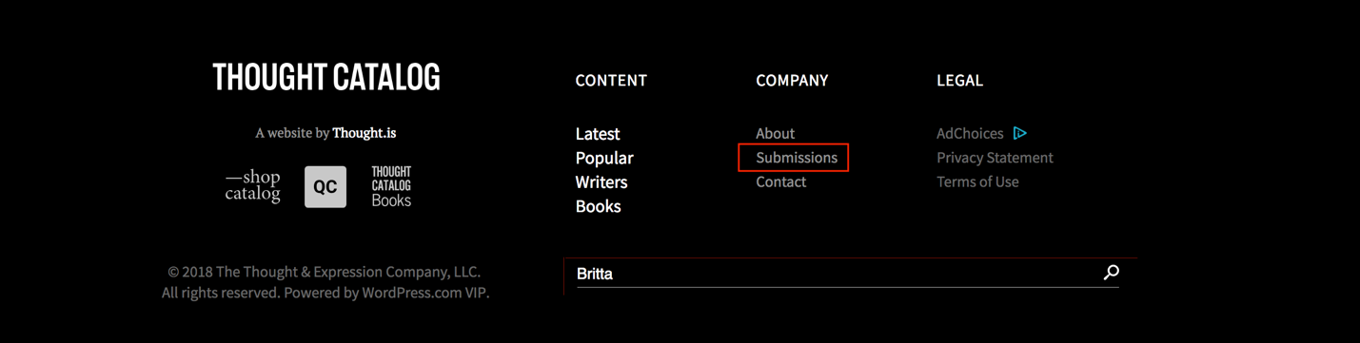
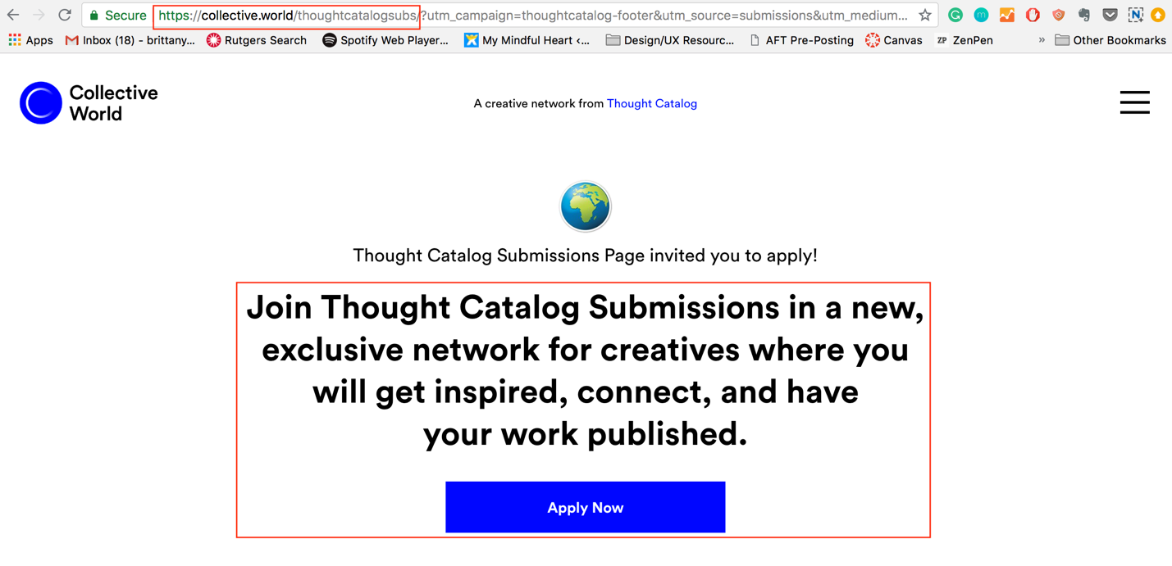

Updated Site Map and Rationale
Relabeling, search position and results improvement, content structure, and overall site consistency all play a roll in what I would like to suggest for ThoughtCatlaog’s ideal site.
Relabeling and Content Structure go hand-in-hand. Much of the current problem with the site as it is now lends to the ambiguous labeling of the navigations and homepage boxes and the lack of (known) categorization of the articles themselves. Most other competitor news/articles sites organize their content with categories like: relationships, friendships, love, lifestyle, current events etc., but ThoughtCatalog seems to organize their content only by: Latest, Popular, Editor Picks, Trending Now etc.. more concise way-finding would greatly benefit the site overall.
I also believe that ThoughtCatalog could greatly benefit from reorganizing their Writers/Authors section by implementing alphabetical search navigation. Currently, the site only separates authors by Featured and All. When you click All, you are presented with 400 pages of people with no way of narrowing down the results.
Search results also seem to have no rhyme or reason. When typed an authors first name into the search bar in the footer, results were just giving a string of articles that seemed to have no relation to my search term; not in the article title or written by an author with that same first name. I’m not particularly sure how their search feature is currently filtered and what database or characterization it pulls from.

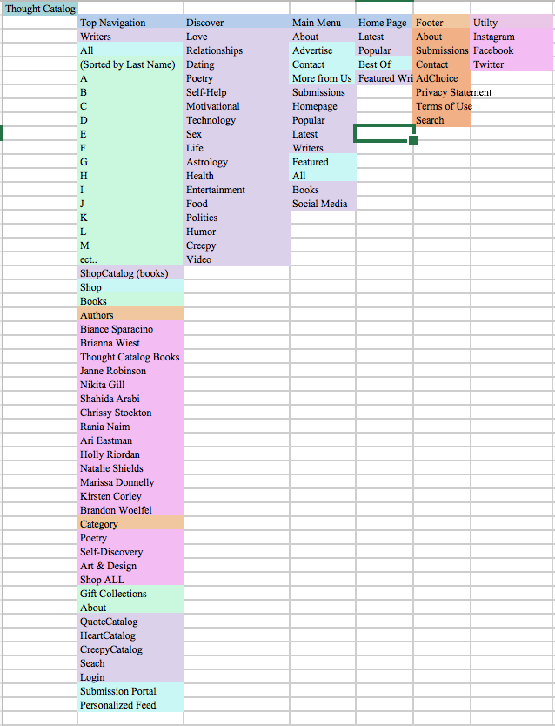

Card Sorting Test

The Card Sorting test proved difficult to conduct. As I was creating the test, choosing the categories and example to test, I was noticing that due to the various way articles are tagged and organized, deciding on how to structure this was a little challenging.

I decided to do a closed card-test as oppose to open, because at this point in the journey, I am trying to tighten up the categories and labeling and I felt doing an open test would present options with a very large range.

I chose to test the below categories to see if users would rather categorize articles by specific topic (love, astrology, self-help) or under the more broad categories ThoughtCatalog tries to implement (HeartCatalog, CreepyCatalog). I also wanted to see if users would associate Trending articles with the “Popular” label, as it exists now, or with the specific top category of the article.

The chart below shows the categories I intended/predicted the users may sorts the cards into and the results matrix from the test show some interesting data.

Categories
- Astrology
- CreepyCatalog
- HeartCatalog
- Latest
- Love
- Popular
- Self-Help
- Writers

Cards | Categories
Here’s Why You Should Never Make Your Worth Dependent On Others By Sylvia Salo 20 hours ago | Latest
To The Girl Who’s Still Waiting For Him To Come Back | Love, HeartCatalog
150 Instagram Bio Ideas That Will Help You Up Your Social Media Game By January Nelson 1 hour ago | Latest
16 Reasons The Virgo + Aquarius Duo Is The Best Zodiac Couple There Is | Astrology
20 Things You Need To Stop Doing To Your Life If You Want To Be Happy | Self-Help
7 Creepy Episodes Of ‘Unsolved Mysteries’ That Have Since Been Solved | CreepyCatalog
Let Me Tell You Why You Should Never Use A Rideshare Service Ever Again | CreepyCatalog
More Stories from ThoughtCatalog Editor, Briana | Writers
Profile: Amanda Andrews | Writers
Read the Best of ThoughtCatalog | Popular
Shop Briana's other titles | Writers
Stop Looking, Love Finds You (Not The Other Way Around) | Love, HeartCatalog
The Destructive Way You Could Self-Sabotage This August, Based On Your Zodiac Sign | Astrology
This is Exactly What a Healthy Relationship Looks LIke | Love, HeartCatalog
This Isn’t A Love Letter, I Swear
Trending: I’m Slowly Learning That I Don’t Have To React To Everything That Bothers Me | Popular, Self-help
Trending: What You Were Supposed To Learn Between 2016 And 2018, Based On Your Zodiac Sign | Popular, Astrology
Trending: I Stopped Chasing You, But I Never Stopped Wanting You | Popular, Love

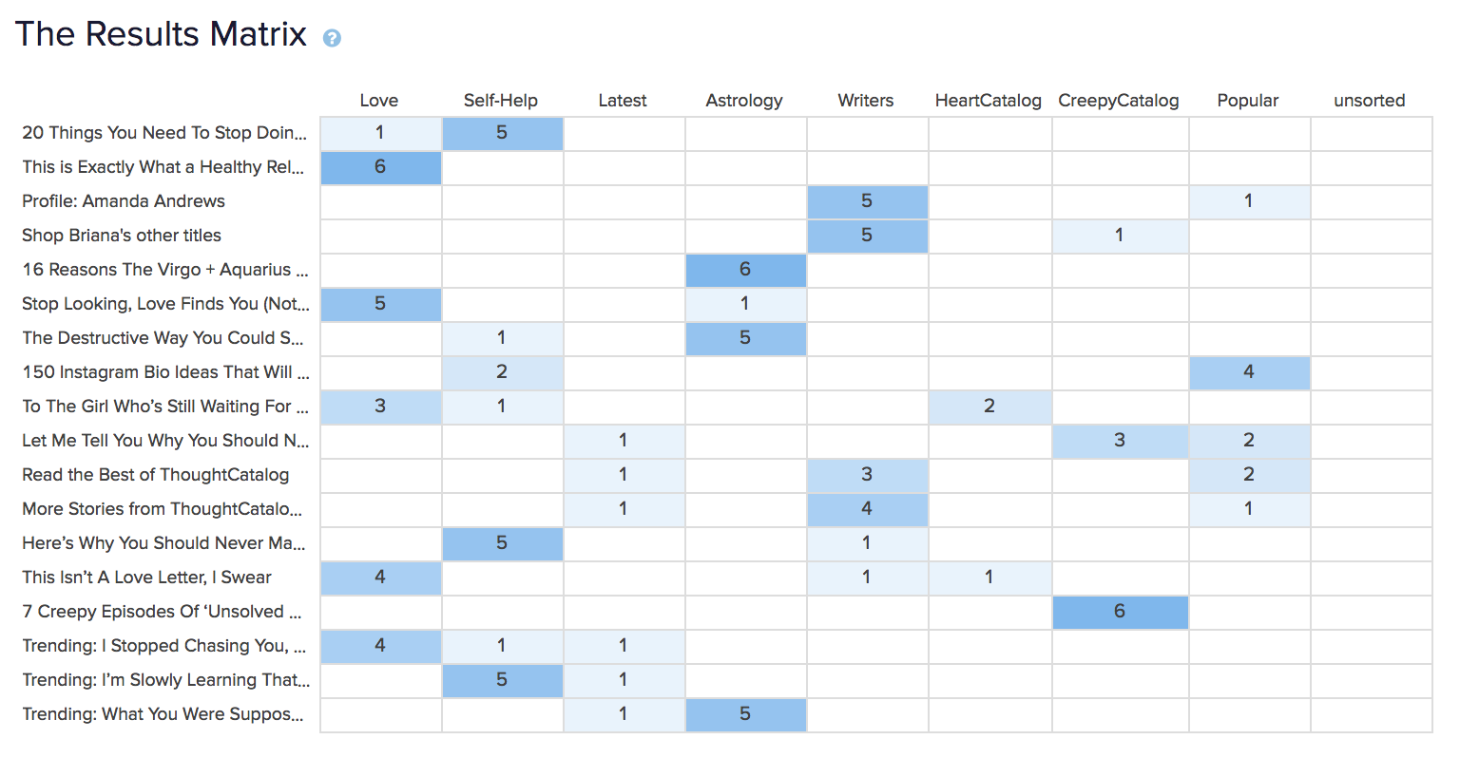
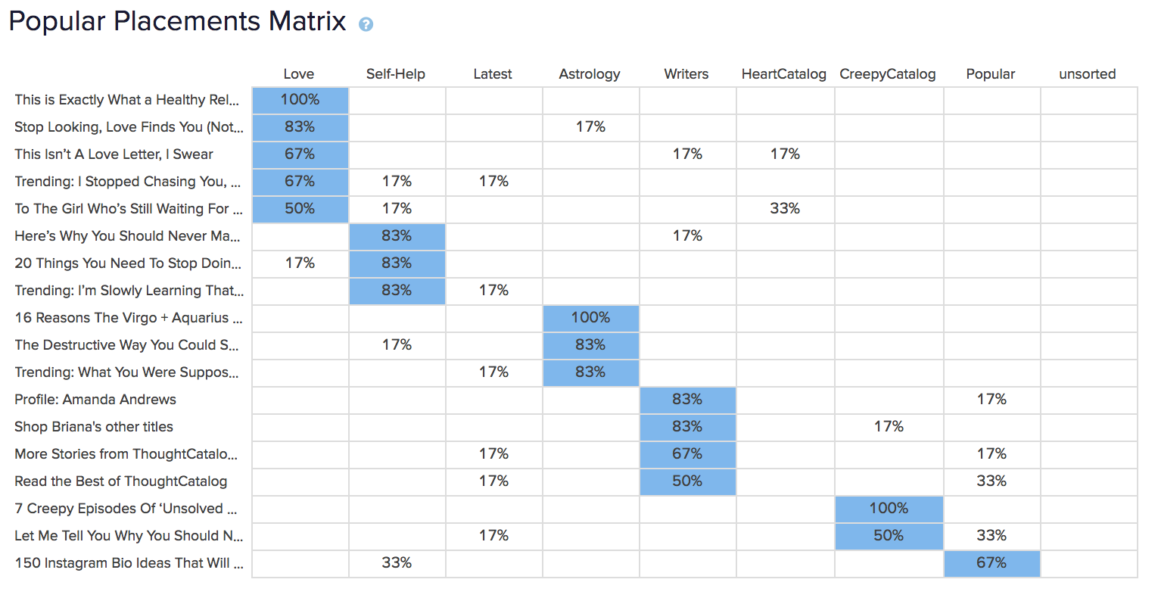

It appears that trending was not associated with popular articles by any of the 7 participants of the test. And articles showing their post time were also not associated with the latest category. Results for the rest of the articles and subjects varied, but a majority of testers chose to put articles under topic titles like love, self-help, astrology.

After this test, I am recommending that the site structure reflect a discover tab with the most popular topics. In order for this to work, ThoughtCatalog will need to restructure how they tag their content and be much more concise. Currently they user 6-10 tags relevant to the title and overall concept of the article, but in order for this categorize to work, they should use the same few broad topic tags instead of very article specific tags.

After performing this test, I’ve slightly updated my suggested sitemap to reflect a more specified structure. If ThoughtCatalog Keeps their “Catalog” theme, I suggest incorporating each of their different Catalogs into the Top Navigation, updating the homepage with latest, popular and featured writers, and not keeping the Writers tab to strictly A-Z writer profiles.

Wireframe: Redesign

The homepage was screen that had the biggest updates. Based on the research and the current theme of the company site, I updated the top navigation and added a side navigation: Discover. This incorportates the acute need for categorization and consistency. The Writers screen was also updated to incorporate the alpabetical scheme organization. This would allow users to better navigate content based on their favorite writers, which is a big element of the site.
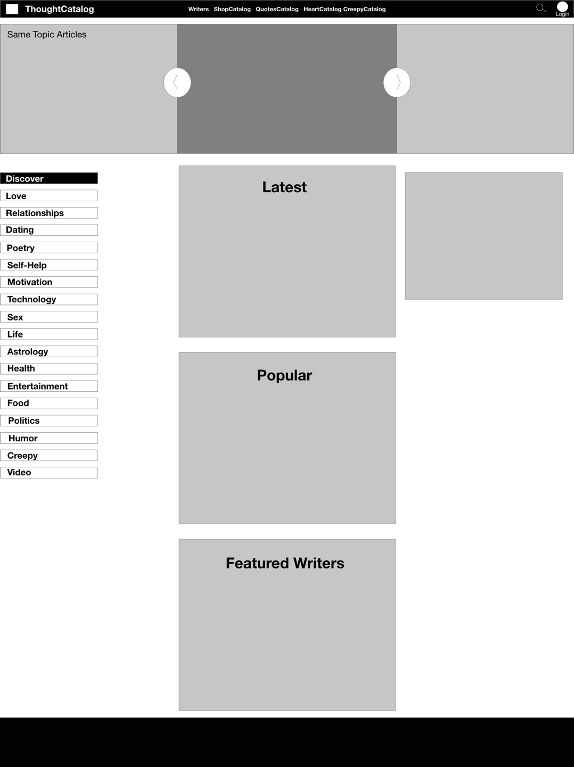
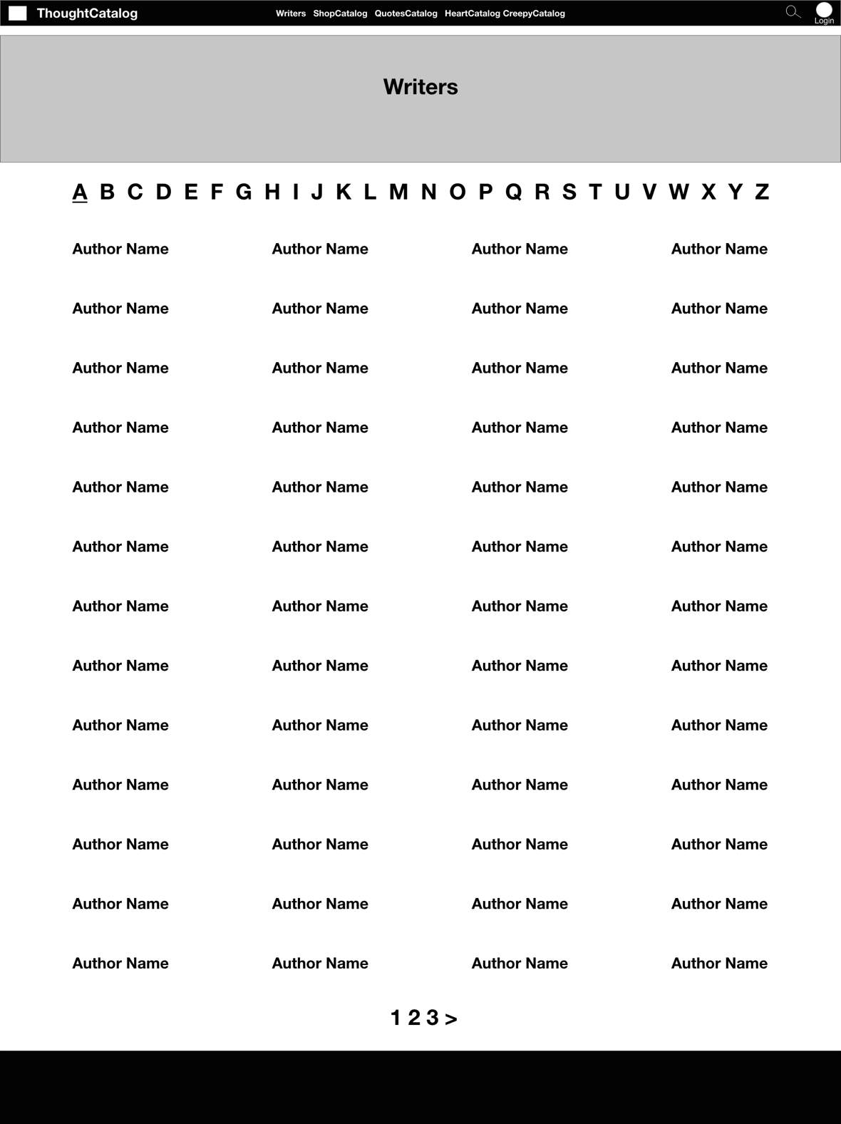

Executive Summary

ThoughtCatalog.com’s main objective is to host articles, personal essays, poetry, short stories and more by established and aspiring writers. They have over 100,000 articles published, over 20,000 writers, and publish books for their featured writers and editors. Due to the nature of their site and their content, the company’s main goal was to be clean and clutter and focus on archival of their cumbersome amount of content; neither of which I felt they were currently achieving.

With that information, I conducted a preliminary analysis of their current website structure and made note of the information on their main pages: home page, latest, writers, articles, and the main menu. This information was able to lend to the my testing and plans for restructure.

I created personas to give the user a voice; create empathy for their journey and purpose in using, accessing and creating content for the site. Having these created while also conducting a competitive analysis helps to guide the tone and aspects I was seeking to compare. I found that most other news and publishing platforms categorized their content by subject matter or topic, which was very important in establishing a baseline for my future recommendations.

I conducted TreeJack tests which helped me understanding the mindset and thought pattern of the potential users. Along with this test, I conducted a card sorting exercises, which also helped to establish the need for more clear, concise labeling updates. I learned from this that much of their current language and headings are ambiguous and can have multiple implications. This research led to the improves I suggested with an updated sitemap, incorporating the addition of a “Discover” navigation feature, to guide site visitors to browse articles by topics, which is not currently an easily accessible feature. I suggested updating their top navigation bar to include the incorporation of their “Catalog” theme: ShopCatalog, HeartCatalog, CreepyCatalog in order to keep their branding message consistent. In this top navigation I also suggested the repositioning of the search feature, currently only found in the footer of the site, and the consolidation of their submission platform into a profile feature of their site; allowing users who submit content to have their own customization and user identification. In the future this could be later adapted to following of specific writers and topics like Medium’s current business structure.

Another noticeable change I recommend is the readaptation of their Writers page. Currently there is a single stream of 400+ pages of contributors (writers), but to help searching, I recommend implementing an alphabetical categorization scheme (by last name preferably as mentioned in the TreeJack testing survey).

Overall, my main areas of improvement lie in relabeling and consistent categorization. This would apply to their homepage, navigation bars, articles, and writers. This study illuminated areas of weakness, but also exhibits solutions to make ThoughtCatalog even more successful for the company and for users.

